PROJECT TITLE HERE

PROJECT REPORT
Submitted by

Group Member1 Name (Reg no.)
Group Member2 Name (Reg no.)
Group Member3 Name (Reg no.)

Prepared For

DATABASE SYSTEMS (BCSE302P) -Lab PROJECT

Submitted To

Dr. Anand Bihari

School of Computer Science and Engineering



Abstract

Table of Contents
Contents
1. Introduction 4
2. Project SCOPE 4
3. Key Contacts and Stakeholders 4
4. Project Resource Requirements 4
4.1 Software Resource Requirements 4
5. ER Diagram 5
6. Tables and Constraints 6
7. SQL Implementation 7
8. Advanced SQL Implementation 7
10. Review Requirements 8
11. Work break down 9
12. REVIEW EVALUATION 9

Introduction
Every educational institution focuses on reduction of malpractices during examinations and there by establish good standards that contribute towards optimized evaluation processes for their students. As a result the institution can gain credibility in the eyes of the industry by reducing the gap in terms of identifying the right candidate for the various opportunities available. The Malpractice Management System is one such system that focuses on effective utilization of resources towards malpractice management thereby catering towards evaluation process optimization for students and faculty.

Project SCOPE

Malpractice Management System aims at automation of the following processes

- Malpractice Registration by faculty members
- Assignment and communication of enquiry committee members
- Status tracking of Reported malpractices by students
- Auto email Generation about the reported malpractice to the proctors and parents of the concerned students
- Report Generation on the malpractices reported for measuring the effectiveness of the examination conduction process.

Key Contacts and Stakeholders
Name | Registration Number | Phone Number/Email
Team Member 1 | 111111111 | 9962545500
Team Member 2 | 222222222 | 8878878777

Project Resource Requirements

Software Resource Requirements
- Windows XP (Service Pack3)
- mysql
- HTML 5
- JavaScript
- PHP5.5
- Apache Web Server
- Rational Rose Enterprise Edition
- 2-Plan
- ArgoUML

ER Diagram
Updated ER diagram required here
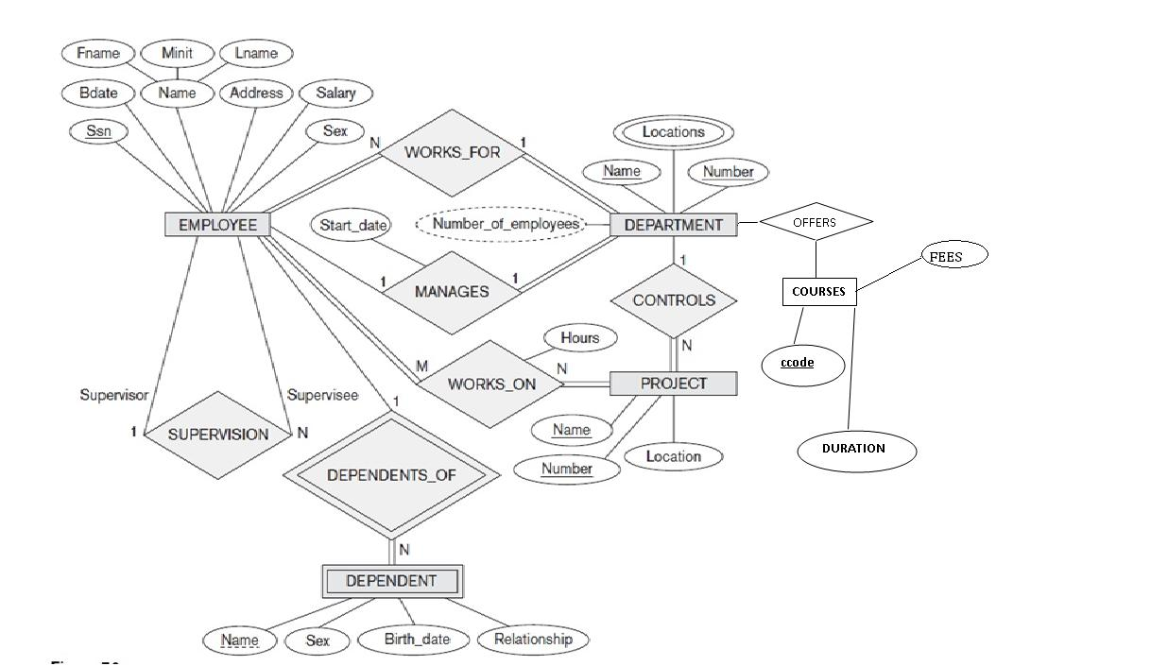

Tables and Constraints

Include a description of each table and explain the relationships between the tables. Specify the normal form satisfied by each table. Also, include screenshots of the table creation statements. Update the table 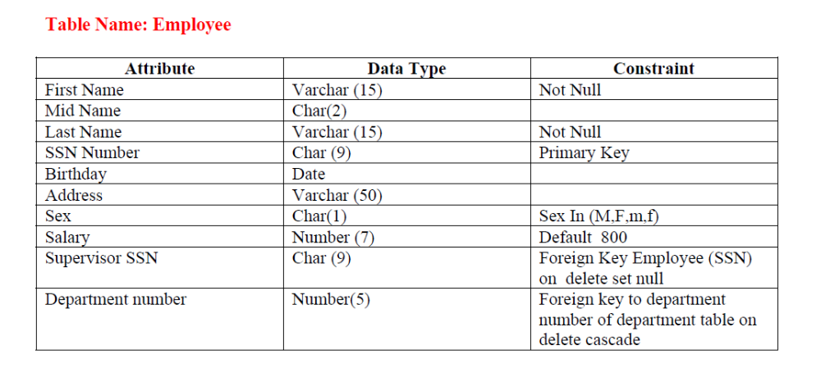

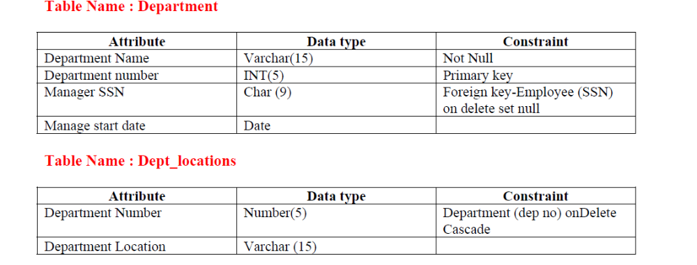

SQL Implementation

They should demonstrate actual implementation, not just design. Include screenshot of each query with at least one ouput.

Category | Required coverage | Min queries
A. Basic | SELECT, WHERE, ORDER BY, DISTINCT, BETWEEN, IN, LIKE, IS NULL | 6
B. Aggregate | COUNT, SUM, AVG, MIN, MAX, GROUP BY, HAVING (must contrast WHERE vs HAVING in one query) | 5
C. Joins | INNER, LEFT, RIGHT, FULL OUTER (or emulation), SELF, CROSS (meaningful use) | 6
D. Subqueries | Scalar, single-row, multi-row (IN/ANY/ALL), correlated, EXISTS, NOT EXISTS, NOT IN (with a note on the NULL pitfall) | 6
E. Set operations | UNION, UNION ALL, INTERSECT, EXCEPT/MINUS (or equivalents) | 4
F. Advanced functions | CASE, COALESCE, NULLIF, date/time, string, numeric functions | 6
G. Window/analytic (recommended for higher band) | RANK, ROW_NUMBER, running total, LAG/LEAD | 2

Advanced SQL Implementation
- Complex Business Queries (minimum 10)
Each must involve ≥ 3 tables or a nested/analytic construct. Use this template per query:
Field | Content
ID | CQ-01
Business question | Plain-language question a manager would ask
SQL | Formatted query
Expected output | Predicted result before execution (hand-reasoned from data)
Actual output screenshot
Explanation | Join logic, filter logic, why this result is correct

- Views (2–3 minimum)
Field | Content
Purpose
CREATE VIEW statement | At least one view joining ≥ 3 tables; at least one aggregated view; one security/row-restricting view
Query using the view
Screenshot
Why useful | Abstraction, security, simplification; state whether the view is updatable and why/why not
- Stored Procedures (at least 2)
- User-Defined Functions (at least 2)
- Triggers (at least 2)
- Cursor (at least 2)
- SQL Security Implementation
Task | Evidence
Create ≥ 3 users/roles | CREATE USER/ROLE script
GRANT privileges per role matrix | Script + SHOW GRANTS / \dp output
REVOKE demonstration | Before/after
Least privilege proof | Login as restricted user → attempt forbidden operation → show error screenshot
Secure exposure | Views/procedures as the only access path for restricted roles

- Review 2 Requirements (checklist)

# | Mandatory component | Evidence
1 | CREATE TABLE scripts + all constraints | 01_ddl.sql runs cleanly
2 | INSERT, UPDATE, DELETE | 02_dml.sql, row-count table
3 | Basic, aggregate, join, subquery, set-operation queries | ≥ 20 queries at this stage
4 | Views | ≥ 2
5 | Transactions (COMMIT/ROLLBACK/SAVEPOINT) | Demonstration script
6 | Procedures/functions | ≥ 1 each working
7 | Triggers | ≥ 1 working
8 | Indexes + one EXPLAIN comparison
9 | Execution screenshots | With SQL
10 | Design changes since Review 1 | Change log with reasons

Review Requirements
Complete database with all tables populated · full scripts (re-runnable from scratch) · advanced SQL · views · procedures · functions · triggers · transactions and concurrency · indexing · query optimization · security implementation · testing (≥ 15 cases) · final report · live demonstration (10–12 min) + individual viva.

Demo flow: (1) run DDL+DML on a clean DB, live (2) role-based access (3) a transactional workflow with a deliberate failure and rollback (4) trigger firing (5) one optimization before/after (6) one concurrency scenario.

Design and screen shot of all working modules of project with all accessible input and output.
Implement indexing to improve the search query.

Performance bands and evaluator anchors
Band | Description
Excellent (≥ 85%) | Justified design, verified correct SQL, optimization with reasoning, anomalies demonstrated, fluent viva
Good (70–84%) | Correct and complete, limited justification or shallow optimization
Satisfactory (50–69%) | Works, but design/analysis is thin or partially unexplained
Poor (< 50%) | Missing components, errors, unexplained or copied work

Work break down
Team Member Registration Number | Name | Work Assigned
1111111 | Member 1 | Functionality 3a,3b
2222222 | Member 2 | Functionality 3c,3d

REVIEW EVALUATION
COMPONENT | MARKS | MEMBER 1 | MEMBER 2 | MEMBER 3
Project work with screenshot | 5
Viva | 5
TOTAL | 10 MARKS

- Individual Viva (20–30 questions; the evaluator picks 5–6 per student)
Marking: each question 0–3 (0 = wrong, 1 = definition only, 2 = correct with example, 3 = correct, justified, connected to own project).
Design and normalization
- Why did you choose <your PK> as the primary key for <table>? What other candidate keys exist and why were they rejected? Why not a natural key?
- Give one functional dependency in your schema and prove it using attribute closure.
- Show an update anomaly that would occur if two of your tables were merged. Which normal form prevents it?
- Is every 3NF relation in your schema also in BCNF? Give one relation where they could differ.
- When would you intentionally denormalize in your project? What risk do you take on?
- Your M:N relationship: what is the primary key of the junction table, and why?
Constraints and integrity
- For which FK did you choose ON DELETE CASCADE, and for which RESTRICT? What disaster occurs if swapped?
- What happens when a parent row referenced by a child row is deleted in your schema? Demonstrate.
- A CHECK constraint on a column allows NULL. Why does CHECK (qty > 0) not reject NULL, and how do you fix it?
- Difference between DELETE, TRUNCATE, and DROP; which can be rolled back in your DBMS, and do triggers/FK rules matter?
Queries
- Your query uses LEFT JOIN. Why not INNER JOIN? Show the row that would be lost.
- WHERE vs HAVING: rewrite one of your queries wrongly and explain the error/result difference.
- NOT IN returns no rows because the subquery contains a NULL. Explain why and give the fix.
- EXISTS vs IN: when does the optimizer treat them differently? Which did you use and why?
- Correlated subquery vs join: rewrite your correlated query as a join; which is faster on 1M rows and why?
- UNION vs UNION ALL: cost difference and when the wrong choice gives wrong results.
- COUNT(*), COUNT(col), COUNT(DISTINCT col) on your data: predict the three results.
Indexes and optimization
- Why did you index (col_a, col_b) in that order? Will the query WHERE col_b = ? use it?
- Give a query in your project where an index exists but will not be used. Why?
- Explain your EXPLAIN output row by row. What join algorithm is used and why?
- Your table has 200 rows and the index gives no speed-up. Why? How would you prove the benefit?
- What is the cost of adding five more indexes to your orders table?
Transactions and concurrency
- Two customers buy the last item simultaneously. Walk through what happens at Read Committed, then how you would prevent overselling.
- Explain a lost update with your own tables and show two ways to prevent it (locking vs isolation vs optimistic versioning).
- Dirty read vs non-repeatable read vs phantom read: which isolation level in your DBMS prevents each? Which anomalies remain at your default level?
- Explain how your DBMS guarantees durability after a power failure (log, checkpoint, fsync).
- How could a deadlock occur in your place_order procedure? How would you avoid it (lock ordering, retry)?
Procedural SQL and security
- Why is your business rule in a stored procedure and not the application? When would a trigger be worse than a procedure? Give a trigger hazard (recursion, hidden side-effects).
- Function vs procedure: why did you implement <X> as a function? Can it be used in SELECT? Can it contain a transaction?
- Why would a set-based UPDATE beat your cursor? When is a cursor still justified?
- A login form builds SELECT * FROM users WHERE name='"+input+"'. Craft the injection, then show two defenses. Why doesn’t GRANT alone protect against it?
- A staff member should see only their branch’s data. Design it with views/roles/privileges without changing application code.
- How are passwords stored in your system? What is wrong with MD5(password)?
- The orders table is accidentally emptied at 3:15 PM. Using your backup strategy, how do you recover to 3:14 PM?

